WordPress: Partial Crawl:Date
Parent page: This week:
Filter: Last Week
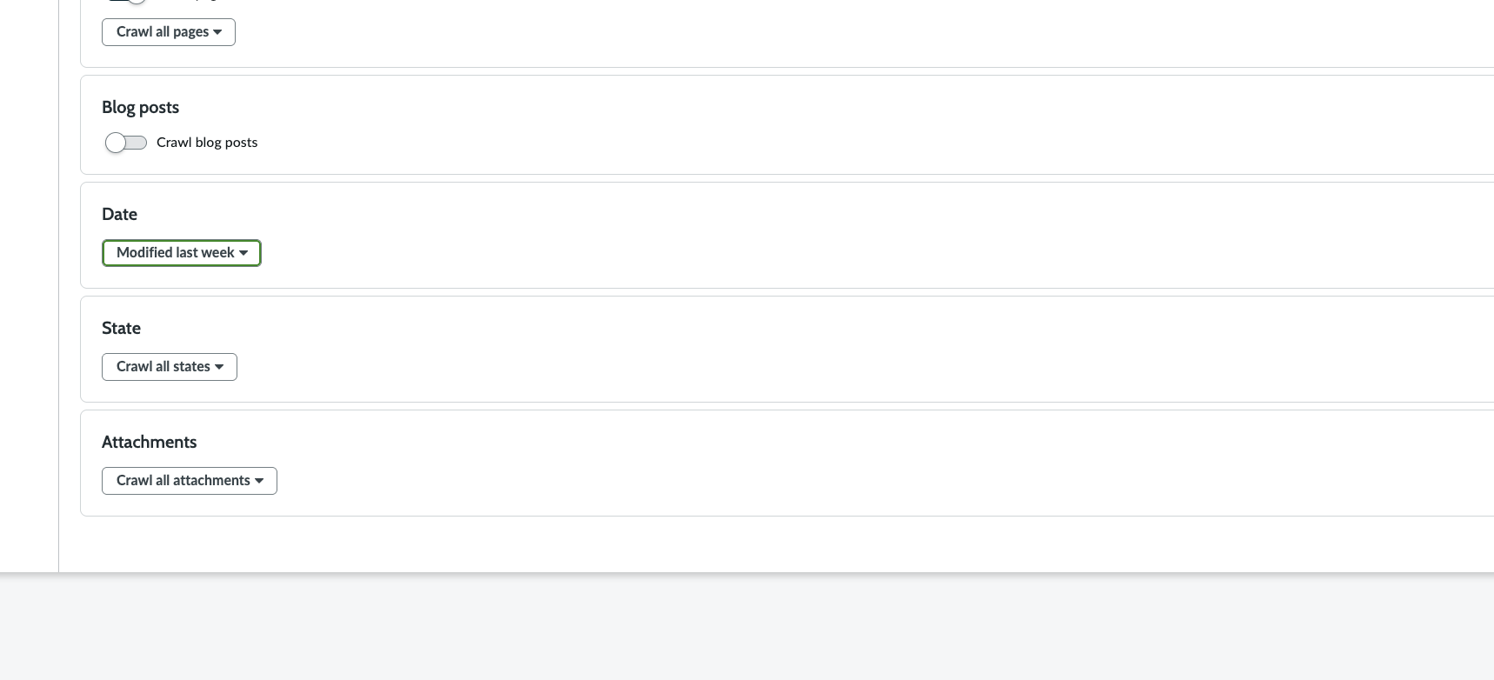
All child and grandchild with current week:
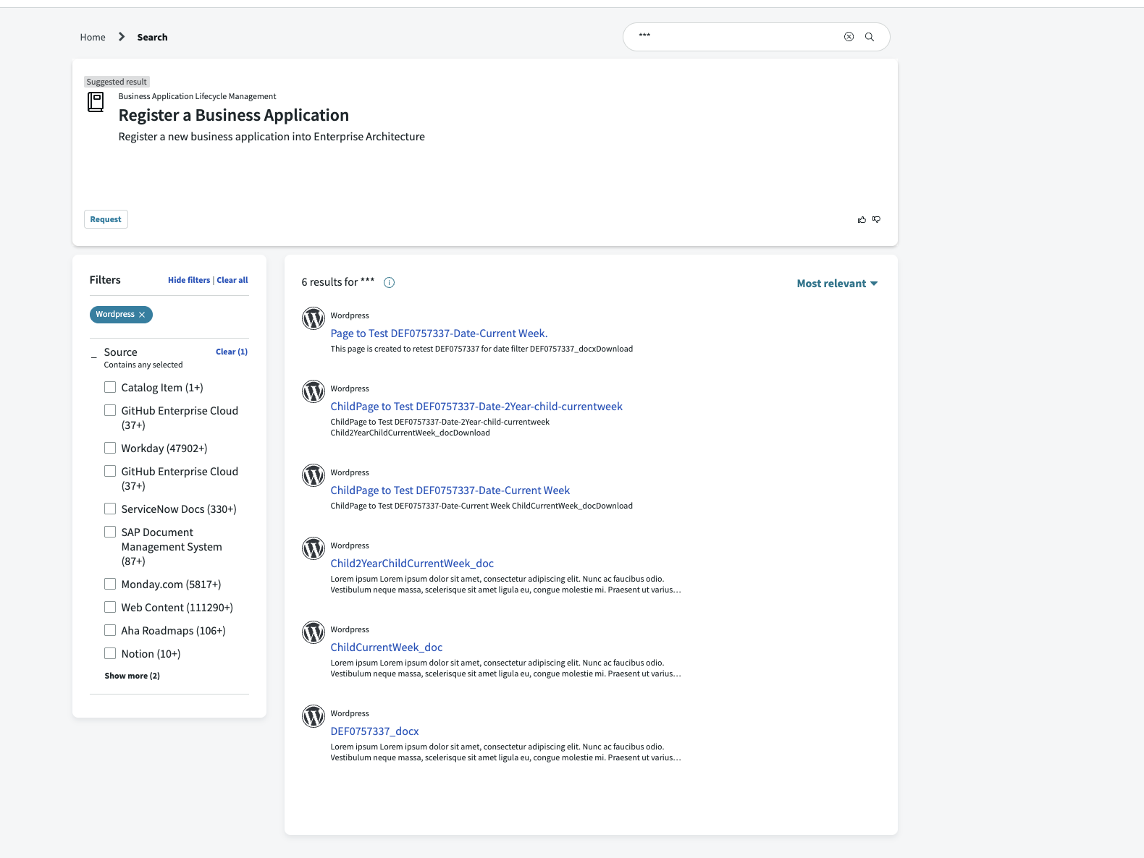

Parent page: This week:
Filter: Last Month
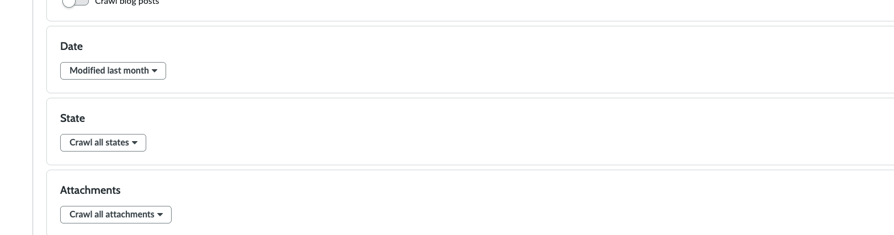
All child and grandchild within 30 days:
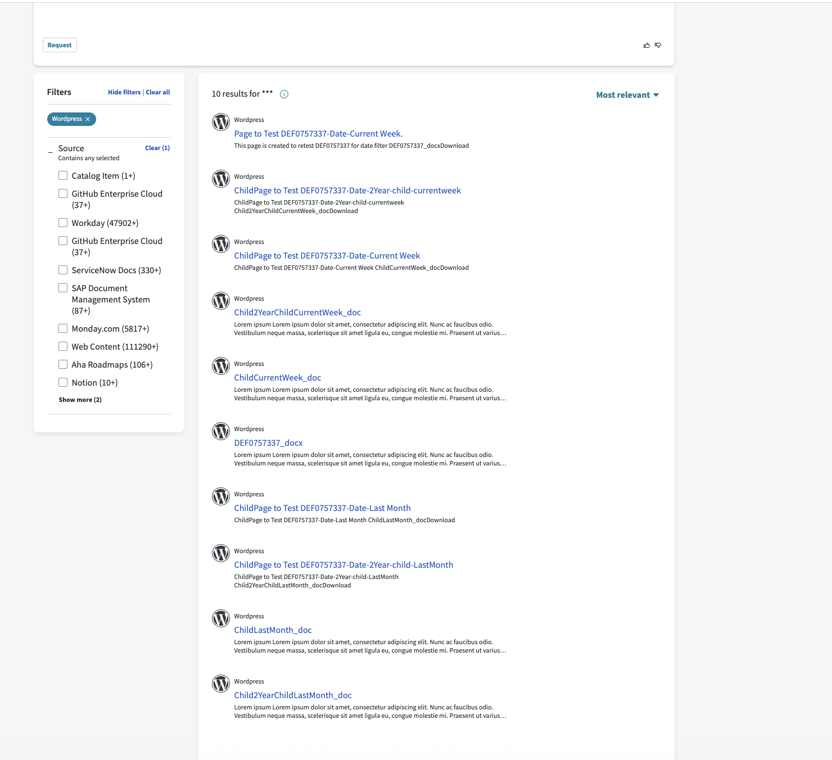

Parent page: This week:
Filter: Last Quarter
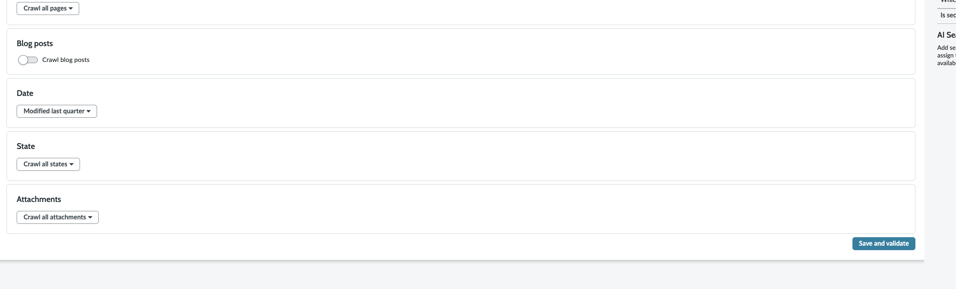

All child and grandchild within last quarter:
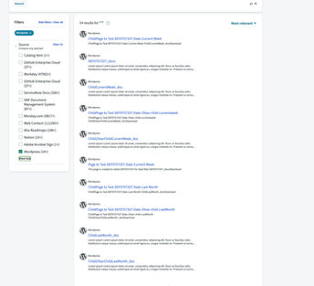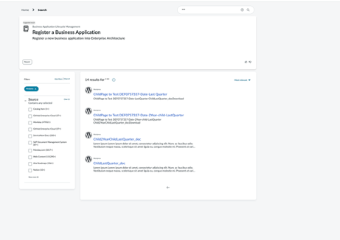

Parent page: This week:
Filter: Last year
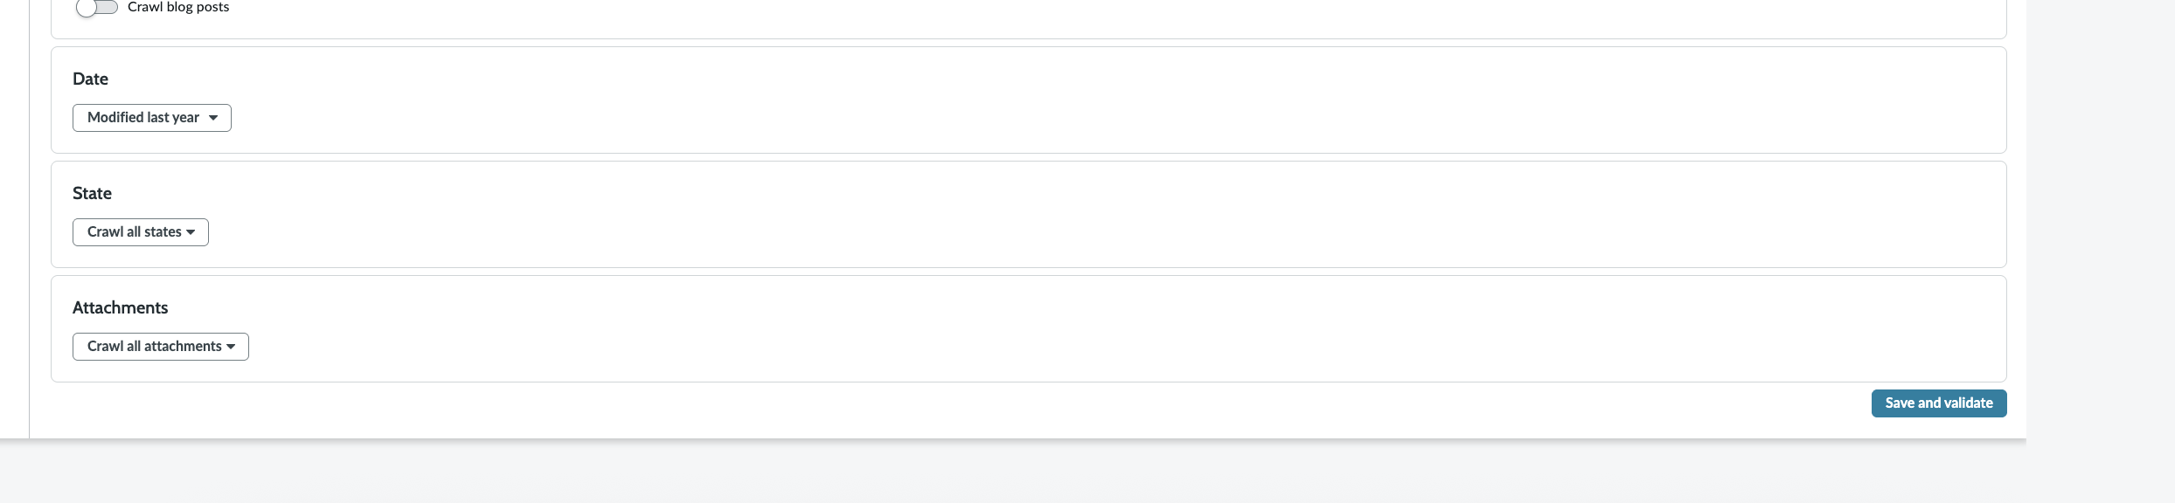

All child and grandchild within last year and no document or attachment older than 1 year is there:
